Chapter 09
Behavioral Finance and Technical Analysis

- Note the following matches
Disposition effect – d
Representativeness bias – e
Regret avoidance – b
Conservatism bias – a
Mental accounting - c
- Representativeness bias. The sample size is not considered when making future decisions.
- Fundamental risk means that even if a security is mispriced, it still can be risky to attempt to exploit the mispricing. This limits the actions of arbitrageurs who take positions in mispriced securities. Thus, the bias may persist since no one takes advantage of it.
- The premise of behavioral finance is that conventional financial theory ignores how real people make decisions and that people make a difference. Behavioral finance may site examples of market inefficiencies, but they give no insight into how to exploit such phenomenon. The strength of their argument relies upon observed market inefficiencies and unexplained market behavior. There are many anomalies, yet many can be reverse engineered or explained. Also, while anomalies exist, they rarely meet the test of statistical significance.
- An unfortunate consequence of behavioral finance (BF) is a tendency for investors to assume more than actually is claimed by the field. While BF is highly critical of EMH and claims to offer alternative theories, it does not propose to be a predictor of future returns. Investors should be wary of people purporting to offer excess returns under the façade of BH. Such claims are likely to be false.
- Statement b, that a price has moved above its 52 week moving average is considered a bullish sign.
- After the fact, you can always find patterns and trading rules that would have generated enormous profits. This is called data mining. For technical analysts, this is a problem since they rarely can be reproduced to predict future profits.
- Grinblatt and Han (2005) show that the disposition effect can lead to momentum in stock prices even if fundamental values follow a random walk. This momentum may not lead to abnormal profits, but may cause capital to flow to investments that appear to benefit from the momentum, in contrast to where it would otherwise flow.
- Arbitrage assumes the ability to initiate trades based on arbitrage information. A severe limit of the theory is that similar assets should be priced similarly (Law of one price). An example of a limit in which such a trade is not possible is the case of Royal Dutch Petroleum and Shell. This is a case of “Siamese twin” companies, where the value was not proportional to the profit distribution. Attempts to profit from the incorrect pricing would result in substantial loss. An equity carve out is another example. In this, the sale of a portion of the company does not necessarily generate the exact percentage one would expect based on the percentage taken from the original company. The last example involved closed end funds that typically sell for less than NAV.
- Some people may say it is consistent with both. This is consistent with efficient markets since the price does approach intrinsic value. Behavioral would say it is consistent since the price slowly approaches intrinsic value after the market has a track record of time showing no other shocks are imminent. Lacking information about another shock, EMH says the price should go directly to the new value. Behavioral finance says that may take time.
- Trin =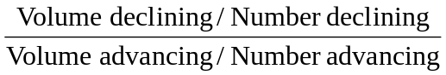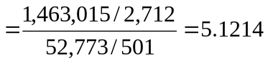
This trin ratio, which is above 1.0, would be taken as a bearish signal.

12. Breadth:
Advances | Declines | Net Declines
501 | 2,712 | 2,211
Breadth is negative. This is a bearish signal (although no one would actually use a one-day measure as in this example).

- This exercise is left to the student.

- The confidence index increases from (8%/9%) = 0.889 to (9%/10%) = 0.900. This indicates slightly higher confidence. But the real reason for the increase in the index is the expectation of higher inflation, not higher confidence about the economy.

- At the beginning of the period, the price of Computers, Inc. divided by the industry index was 0.39; by the end of the period, the ratio had increased to 0.50. As the ratio increased over the period, it appears that Computers, Inc. outperformed other firms in its industry. The overall trend, therefore, indicates relative strength, although some fluctuation existed during the period, with the ratio falling to a low point of 0.33 on day 19.

- Five day moving averages:
Days 1 – 5: (19.63 + 20 + 20.5 + 22 + 21.13) / 5 = 20.65
Days 2 – 6 = 21.13
Days 3 – 7 = 21.50
Days 4 – 8 = 21.90
Days 5 – 9 = 22.13
Days 6 – 10 = 22.68
Days 7 – 11 = 23.18
Days 8 – 12 = 23.45 ← Sell signal (day 12 price < moving average)
Days 9 – 13 = 23.38
Days 10 – 14 = 23.15
Days 11 – 15 = 22.50
Days 12 – 16 = 21.65
Days 13 – 17 = 20.95
Days 14 – 18 = 20.28
Days 15 – 19 = 19.38
Days 16 – 20 = 19.05
Days 17 – 21 = 18.93 ← Buy signal (day 21 price > moving average)
Days 18 – 22 = 19.28
Days 19 – 23 = 19.93
Days 20 – 24 = 21.05
Days 21 – 25 = 22.05
Days 22 – 26 = 23.18
Days 23 – 27 = 24.13
Days 24 – 28 = 25.13
Days 25 – 29 = 26.00
Days 26 – 30 = 26.80
Days 27 – 31 = 27.45
Days 28 – 32 = 27.80
Days 29 – 33 = 27.90 ← Sell signal (day 33 price < moving average)
Days 30 – 34 = 28.20
Days 31 – 35 = 28.45
Days 32 – 36 = 28.65
Days 33 – 37 = 29.05
Days 34 – 38 = 29.25
Days 35 – 39 = 29.00
Days 36 – 40 = 28.75

Buy
30 |  |  | X
28 |  |  | X | 0
26 |  |  | X

24 | X |  | X
22 | X | 0 | X
20 | X | 0 | X
18 |  | 0 | X
16
Sell
A sell signal occurs at a price of approximately $19, which is similar to a sell signal derived from the moving average rule. However, the buy signals are not the same.

- This pattern shows a lack of breadth. Even though the index is up, more stocks declined than advanced, which indicates a “lack of broad-based support” for the rise in the index.

Day | Advances | Declines | Net Advances | Cumulative Breadth
1 | 906 | 704 | 202 | 202
2 | 653 | 986 | -333 | -131
3 | 721 | 789 | - 68 | -199
4 | 503 | 968 | -465 | -664
5 | 497 | 1,095 | -598 | -1,262
6 | 970 | 702 | 268 | -994
7 | 1,002 | 609 | 393 | -601
8 | 903 | 722 | 181 | -420
9 | 850 | 748 | 102 | -318
10 | 766 | 766 | 0 | -318
The signal is bearish as cumulative breadth is negative; however, the negative number is declining in magnitude, indicative of improvement. Perhaps the worst of the bear market has passed.

- Trin =
This is a slightly bullish indicator, with average volume in advancing issues a bit greater than average volume in declining issues.

- Confidence Index = 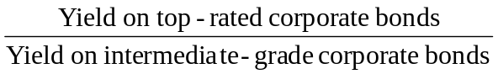
This year: Confidence Index = (8%/10.5%) = 0.762
Last year: Confidence Index = (8.5%/10%) = 0.850
Thus, the confidence index is decreasing.
- [Note: In order to create the 26-week moving average for the S&P 500, we first converted the weekly returns to weekly index values, using a base of 100 for the week prior to the first week of the data set.]
a. The graph on the next page summarizes the data for the 26-week moving average. The graph also shows the values of the S&P 500 index.
b. The S&P 500 crosses through its moving average from below fifteen times, as indicated in the table below. The index increases eight times in weeks following a cross-through and decreases seven times.
c. The S&P 500 crosses through its moving average from above sixteen times, as indicated in the table below. The index increases ten times in weeks following a cross-through and decreases six times.
d. It is obvious from the data presented that the rule did not work in recent years.
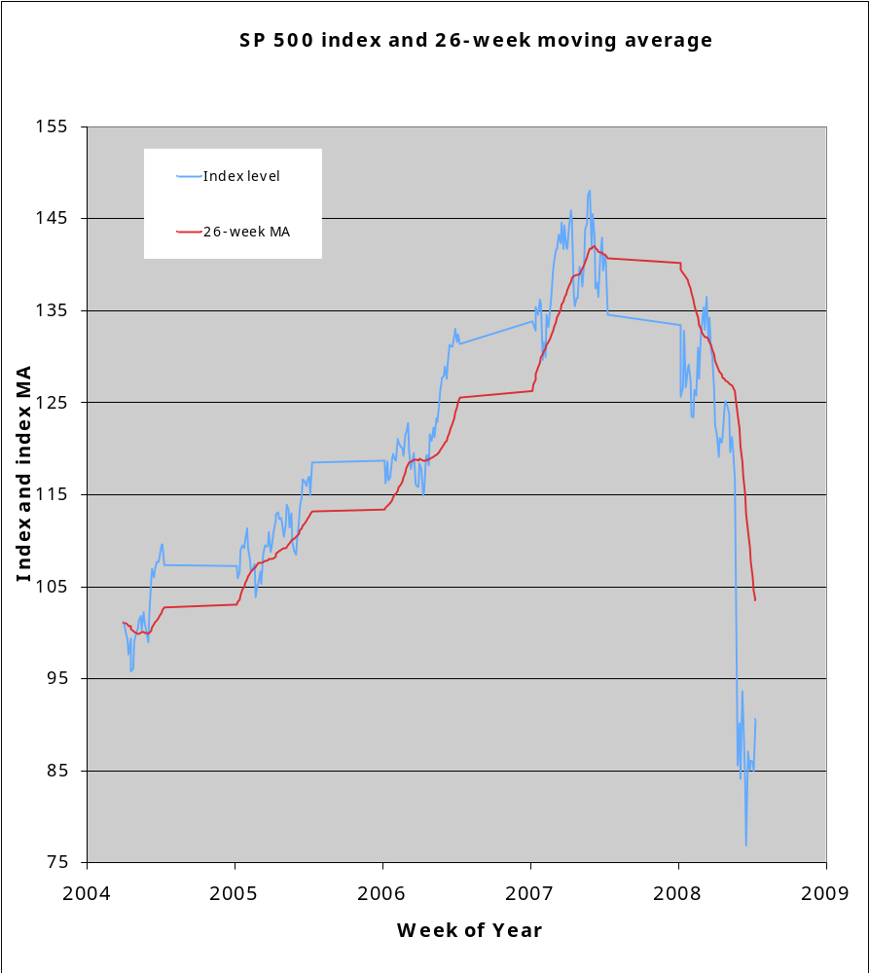

- [Note: In order to create the relative strength measure, we convert the weekly returns for the Fidelity Banking Fund and for the S&P 500 to base 100 weekly index values.]
a. The graphs summarize the relative strength data for the Fidelity Banking Fund.
b. Over five-week intervals, relative strength increased by more than 5% sixteen times, out of 255 instances. The Fidelity Banking Fund underperformed the S&P 500 index ten times and outperformed the S&P 500 index six times in weeks following an increase of more than 5%.
c. Over five-week intervals, relative strength decreases by more than 5% thirty one times, out of 255 instances. The Fidelity Banking Fund underperformed the S&P 500 index seventeen times and outperformed the S&P 500 index fourteen times in weeks following a decrease of more than 5%.
d. An increase in relative strength, as in part (b) above, is regarded as a bullish signal. However, in our sample, the Fidelity Banking Fund is more likely to under perform the S&P 500 index than it is to outperform the index following such a signal. A decrease in relative strength, as in part (c), is regarded as a bearish signal. In our sample, the Fidelity Banking Fund underperformed the index as expected. However, there is no statistical difference in the performance following a substantial change in the relative strength. The subsequent performance appears to be random.
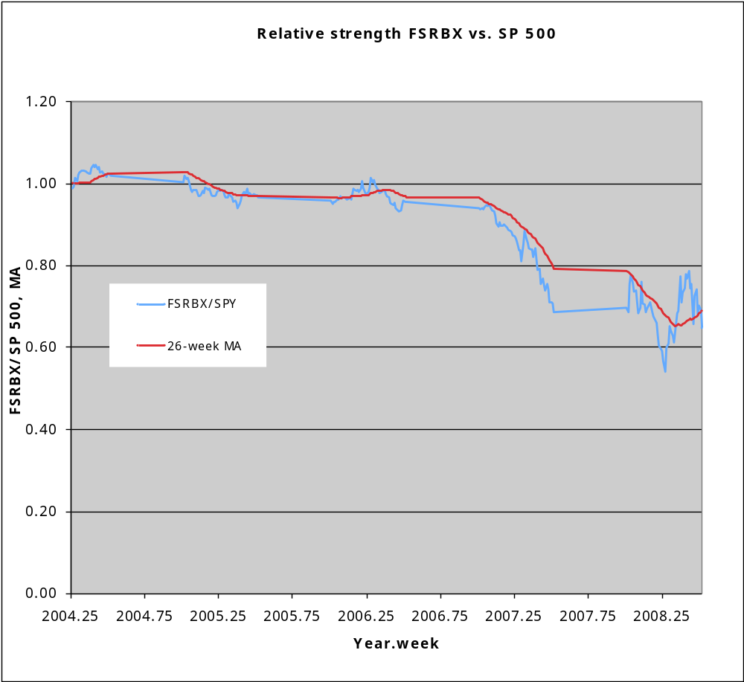
- Pontiff (1996) demonstrates that deviations of price from net asset value in closed-end funds tend to be higher in funds that are more difficult to arbitrage, for example, those with more idiosyncratic volatility. Since well diversified funds represent less of an opportunity for arbitrage by removing the impact of individual stock anomalies, they would likely have smaller deviations from NAV.

CFA 1
- Mental accounting is best illustrated by Statement #3. Sampson’s requirement that his income needs be met via interest income and stock dividends is an example of mental accounting. Mental accounting holds that investors segregate funds into mental accounts (e.g., dividends and capital gains), maintain a set of separate mental accounts, and do not combine outcomes; a loss in one account is treated separately from a loss in another account. Mental accounting leads to an investor preference for dividends over capital gains and to an inability or failure to consider total return.
- Overconfidence (illusion of control) is best illustrated by Statement #6. Sampson’s desire to select investments that are inconsistent with his overall strategy indicates overconfidence. Overconfident individuals often exhibit risk-seeking behavior. People are also more confident in the validity of their conclusions than is justified by their success rate. Causes of overconfidence include the illusion of control, self-enhancement tendencies, insensitivity to predictive accuracy, and misconceptions of chance processes.
iii. Reference dependence is best illustrated by Statement #5. Sampson’s desire to retain poor performing investments and to take quick profits on successful investments suggests reference dependence. Reference dependence holds that investment decisions are critically dependent on the decision-maker’s reference point. In this case, the reference point is the original purchase price. Alternatives are evaluated not in terms of final outcomes but rather in terms of gains and losses relative to this reference point. Thus, preferences are susceptible to manipulation simply by changing the reference point.

CFA 2
a. Frost's statement is an example of reference dependence. His inclination to sell the international investments once prices return to the original cost depends not only on the terminal wealth value, but also on where he is now, that is, his reference point. This reference point, which is below the original cost, has become a critical factor in Frost’s decision.
In standard finance, alternatives are evaluated in terms of terminal wealth values or final outcomes, not in terms of gains and losses relative to some reference point such as original cost.

b. Frost’s statement is an example of susceptibility to cognitive error, in at least two ways. First, he is displaying the behavioral flaw of overconfidence. He likely is more confident about the validity of his conclusion than is justified by his rate of success. He is very confident that the past performance of Country XYZ indicates future performance. Behavioral investors could, and often do, conclude that a five-year record is ample evidence to suggest future performance. Second, by choosing to invest in the securities of only Country XYZ, Frost is also exemplifying the behavioral finance phenomenon of asset segregation. That is, he is evaluating Country XYZ investment in terms of its anticipated gains or losses viewed in isolation.
Individuals are typically more confident about the validity of their conclusions than is justified by their success rate or by the principles of standard finance, especially with regard to relevant time horizons. In standard finance, investors know that five years of returns on Country XYZ securities relative to all other markets provide little information about future performance. A standard finance investor would not be fooled by this “law of small numbers.” In standard finance, investors evaluate performance in portfolio terms, in this case defined by combining the Country XYZ holding with all other securities held. Investments in Country XYZ, like all other potential investments, should be evaluated in terms of the anticipated contribution to the risk- reward profile of the entire portfolio.

c. Frost’s statement is an example of mental accounting. Mental accounting holds that investors segregate money into mental accounts (e.g., safe versus speculative), maintain a set of separate mental accounts, and do not combine outcomes; a loss in one account is treated separately from a loss in another account. One manifestation of mental accounting, in which Frost is engaging, is building a portfolio as a pyramid of assets, layer by layer, with the retirement account representing a layer separate from the “speculative” fund. Each layer is associated with different goals and attitudes toward risk. He is more risk averse with respect to the retirement account than he is with respect to the “speculative” fund account. The money in the retirement account is a down side protection layer, designed to avoid future poverty. The money in the “speculative” fund account is the upside potential layer, designed for a chance at being rich.
In standard finance, decisions consider the risk and return profile of the entire portfolio rather than anticipated gains or losses on any particular account, investment, or class of investments. Alternatives should be considered in terms of final outcomes in a total portfolio context rather than in terms of contributions to a “safe” or a “speculative” account. Standard finance investors seek to maximize the mean-variance structure of the portfolio as a whole and consider covariances between assets as they construct their portfolios. Standard finance investors have consistent attitudes toward risk across their entire portfolio.

CFA 3
a. Illusion of knowledge: Maclin believes he is an expert on, and can make accurate forecasts about, the real estate market solely because he has studied housing market data on the Internet. He may have access to a large amount of real estate-related information, but he may not understand how to analyze the information nor have the ability to apply it to a proposed investment.
Overconfidence: Overconfidence causes us to misinterpret the accuracy of our information and our skill in analyzing it. Maclin has assumed that the information he collected on the internet is accurate without attempting to verify it or consult other sources. He also assumes he has skill in evaluating and analyzing the real estate-related information he has collected, although there is no information in the question that suggests he possesses such ability.

b. Reference point: Maclin’s reference point for his bond position is the purchase price, as evidenced by the fact that he will not sell a position for less than he paid for it. This fixation on a reference point, and the subsequent waiting for the price of the security to move above that reference point before selling the security, prevents Maclin from undertaking a risk/return-based analysis of his portfolio position.

c. Familiarity: Maclin is evaluating his holding of company stock based on his familiarity with the company rather than on sound investment and portfolio principles. Company employees, because of this familiarity, may have a distorted perception of their own company, assuming a “good company” will also be a good investment. Irrational investors believe an investment in a company with which they are familiar will produce higher returns and have less risk than non-familiar investments.
Representativeness: Maclin is confusing his company (which may well be a good company) with the company’s stock (which may or may not be an appropriate holding for his portfolio and/or a good investment) and its future performance. This can result in employees’ overweighting their company stock, resulting in an under-diversified portfolio

CFA 4
a. The behavioral finance principle of biased expectations/overconfidence is most consistent with the investor’s first statement. Petrie stock provides a level of confidence and comfort for the investor because of the circumstances in which she acquired the stock and her recent history with the returns and income from the stock. However, the investor exhibits overconfidence in the stock given the needs of the Trust and the brevity of the recent performance history. Maintaining a 15 percent position in a single stock is inconsistent with the overall strategy of the Trust, and the investor’s level of confidence should reflect the stock’s overall record, not just the past two years.

b. The behavioral finance principle of mental accounting is most consistent with the investor’s second statement. The investor has segregated the monies distributed from the Trust into two “accounts”: the returns the Trust receives from the Petrie stock, and the remaining funds that the Trust receives for her benefit. She is maintaining a separate set of mental accounts with regard to the total funds distributed. The investor’s “specific uses” should be viewed in the overall context of the spending needs of the Trust and should consider the risk and return profile of the entire Trust.

CFA 5
i. Overconfidence (Biased Expectations and Illusion of Control): Pierce is basing her investment strategy for supporting her parents on her confidence in the economic forecasts. This is a cognitive error reflecting overconfidence in the form of both biased expectations and an illusion of control. Pierce is likely more confident in the validity of those forecasts than is justified by the accuracy of prior forecasts. Analysts’ consensus forecasts have proven routinely and widely inaccurate. Pierce also appears to be overly confident that the recent performance of the Pogo Island economy is a good indicator of future performance. Behavioral investors often conclude that a short track record is ample evidence to suggest future performance.
Standard finance investors understand that individuals typically have greater confidence in the validity of their conclusions than is justified by their success rate. The calibration paradigm, which compares confidence to predictive ability, suggests that there is significantly lower probability of success than the confidence levels reported by individuals. In addition, standard finance investors know that recent performance provides little information about future performance and are not deceived by this “law of small numbers.”

ii. Loss Aversion (Risk Seeking): Pierce is exhibiting risk aversion in deciding to sell the Core Bond Fund despite its gains and favorable prospects. She prefers a certain gain over a possibly larger gain coupled with a smaller chance of a loss. Pierce is exhibiting loss aversion (risk seeking) by holding the High Yield Bond Fund despite its uncertain prospects. She prefers the modest possibility of recovery coupled with the chance of a larger loss over a certain loss. People tend to exhibit risk seeking, rather than risk aversion, behavior when the probability of loss is large. There is considerable evidence indicating that risk aversion holds for gains and risk seeking behavior holds for losses, and that attitudes toward risk vary depending on particular goals and circumstances.
Standard finance investors are consistently risk averse, and systematically prefer a certain outcome over a gamble with the same expected value. Such investors also take a symmetrical view of gains and losses of the same magnitude, and their sensitivity (aversion) to changes in value is not a function of a specified value reference point.

iii. Reference Dependence: Pierce’s inclination to sell her Small Company Fund once it returns to her original cost is an example of reference dependence. Her sell decision is predicated on the current value as related to original cost, her reference point. Her decision does not consider any analysis of expected terminal value or the impact of this sale on her total portfolio. This reference point of original cost has become a critical but inappropriate factor in Pierce’s decision.
In standard finance, alternatives are evaluated in terms of terminal wealth values or final outcomes, not in terms of gains and losses relative to a reference point such as original cost. Standard finance investors also consider the risk and return profile of the entire portfolio rather than anticipated gains or losses on any particular investment or asset class.

